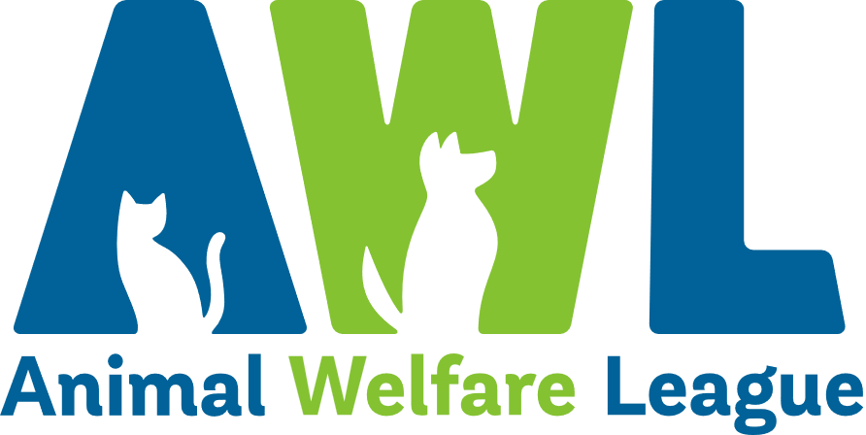
Position Description
Our Vision Our Mission
A South Australia where every pet has a loving home. Connecting pets, people and community.
About Us
Since our humble beginnings in 1964, Animal Welfare League has grown into one of South Australia’s leading animal welfare organisations. In our mission to connect pets, people and community, we find loving homes for vulnerable animals in need, reunite lost animals with their families and provide temporary shelter through our foster care program. We offer education and pet advice to the community to encourage responsible pet ownership and our social enterprises provide much-needed support to South Australians looking for pet boarding facilities and pet cremation and memorial services, as well as those on the lookout for a bargain at our Thrift Shops.

Create Opportunities | Show Compassion | Be Optimistic | Share Knowledge | Walk the Talk
Finding solutions to challenges  Being open minded to alternatives and new approaches  Striving to do better | Listening, observing and offering support  Being respectful  Being empathetic by taking the time to understand others’ points of view | Maintaining a positive outlook  Focusing on what’s possible and staying realistic  Remaining calm and composed during challenging times | Communicating openly and constructively  Using mistakes and feedback as an opportunity to learn  Seeking opportunities to develop our abilities and knowledge | Being open, honest and professional  Being accountable for outcomes and actions  Recognising and celebrating achievements
Our Beliefs and Behaviours
Position Description
Position Title: | Animal Care Coordinator | Tenure: | Ongoing – Full Time
Department: | Animal Operations | Classification: | Level 3
Reports to: | Animal Care Manager(s) | Direct Reports: | Up to 15 direct reports

Position Overview
The Animal Care Coordinator is responsible for ensuring the provision of high quality care for animals at Animal Welfare League of South Australia Inc. (AWL) and provide leadership and supervision to animal care employees and volunteers who provide direct care for these animals.

Key Results Area
- Assist with the coordination of the day-to-day operations of the Animal Care Centre and Edinburgh North, Shelter.  - Oversee the intake and assessment of all incoming animals.  - Provide leadership and direction to the animal care team.  - Assist with the development of rosters in collaboration with other Animal Care Coordinators and Animal Care Managers(s) based on animal occupancy and animal care requirements.  - Ensure all daily animal husbandry tasks carried out by the animal care employees and volunteers including but not limited to feeding, cleaning, bedding, bathing, grooming, weighing and all other routine care tasks for animals in AWL’s care.  - Ensure electronic time and attendance records for animal care employees and volunteers are accurate and complete at the end of every shift.  - Coordinate the routine preventative treatments of all animals in AWL’s care under the direction of the veterinary team.  - Supervise the daily cleanliness and efficiency of the Animal Care Centre and Edinburgh North, Shelter.  - Assist with establishing and coordinating work schedules to ensure accomplishment of essential animal care tasks.  - Assist with Animal and Customer Care Attendant duties as required. | - Issue instructions/directions to animal care employees and volunteers, examine work results and provide training and feedback to improve performance where required.  - Coordinate the distribution of appropriate animals to PetStock stores for adoption in collaboration with Veterinary, Logistics and Foster Care teams.  - Liaise with PetStock regarding any issues arising with the animals in their care, including training of employees in required standards of care.  - Establish, monitor and review reporting processes to ensure correct billing and adoption reporting for PetStock adoptions.  - Provide regular reporting as directed regarding the PetStock adoptions program.  - Ensure all tasks/duties carried out are completed efficiently, competently and accurately to ensure timeframes are met.  - Ensure employees are appropriately inducted, and adequately supervised and trained to competently perform the required duties/functions within their position descriptions.  - Exhibit a professional image of AWL by engaging in effective, professional, respectful and courteous interactions through email, telephone or face-to-face with all internal and external stakeholders.  - Undertake other position appropriate duties as assigned/directed.

Leadership Effectiveness | Personal Abilities
As a manager or supervisor of individuals you will be required to:  Safety Leadership  Leads positive safety attitudes and behaviours and communicates consistently about the pre-eminent importance of safety.  Strategic Thinking and Direction  Commitment to AWL’s vision, mission and beliefs, and understands, contributes to and aligns work/priorities to business strategies.  Commercial Acumen  Understands key business drivers and marketplace and can anticipate trends and broaden knowledge.  Working across Boundaries  Recognises own impact and can influence others, build alliances and model effective workplace collaboration.  Accountability  Defines and tracks performance to achieve goals, whilst driving the culture of innovation, creativity and ‘can-do’.  Leadership and Self-Management  Facilitates involvement and team effectiveness and shares a compelling vision whilst giving guidance, feedback and encouraging development. Able to respond calmly and manage stress, operating with honesty and integrity. | Essential  - Demonstrated understanding of and interest in animal related issues particularly relating to animal welfare.  - Experience coordinating teams of employees and volunteers to deliver efficient, timely and exemplary customer service.  - Excellent time management skills with the ability to prioritise own workload and adjust team priorities to ensure team KPIs and deadlines are met.  - Excellent problem-solving skills with the ability to think analytically and develop solutions to problems.  - Ability to learn, organise, plan and implement programs.  - Proven ability to create, implement and foster a positive, productive and respectful workplace culture including positively influencing change.  - Ability to work independently with minimal supervision, and collaboratively and cooperatively within a team environment.  - Ability to operate within a highly structured environment with a focus on policies and procedures.  - High level of written and verbal communication skills with strong attention to detail and accuracy.  - Experience performing operational and personnel management functions in order to effectively utilise the material and human resources associated with an animal care facilities or related area.  - Ability to understand and interpret relevant policies, procedures, legislation, enterprise agreements and modern awards in relation to Animal Care and ownership and personnel.  Desirable  - Extensive experience in an animal care or related field is preferred.  - Intermediate computer literacy including proficiency with database management and ShelterMate / ShelterBuddy is desirable.
Special Requirements | WHS and Compliance
- Some flexibility with working hours will be required. This includes working across a fourteen (14) day roster including weekends and public holidays.  - Additional hours may be required to meet business needs.  - Travel will be required across AWL sites and other locations.  - A current driver’s licence is desirable.  - Applicants must be functionally assessed to ensure physical ability to complete the physical demands of the position.  - Satisfactory National Police Clearance Certificate / National Police Check (NPC) at commencement of employment and periodically at the request of AWL. | All managers and employees of AWL are to:  - Comply with AWL’s organisational policies, procedures, guidelines and applicable legislative requirements including but not limited to Fair Work Act 2009 and Work Health and Safety Act 2012.  - At all times act and comply with reporting obligations arising from legislation, professional conduct standards including the Code of Code for AWL and organisational policies, procedures and guidelines.  - Take appropriate steps to protect themselves from risks to health and safety and to make sure they do not cause risk to others through any act or omission. In particular, the incumbent must:  - Report accidents, injuries, property damage and health and safety incidents.  - Use equipment provided to protect health and safety.  - Follow reasonable instructions given on health and safety.  - Ensure they are not affected by alcohol or drugs so as to not endanger themselves or others.  - Understand and follow the requirements of confidentiality and facilitate appropriate standards of confidentiality and information sharing practice.  - Actively participate in AWL personal achievement and development processes.  - Participate in training and development activities as specified by AWL including those associated with workplace health and safety.

I have read the requirements and responsibilities outlined in this position description and will adhere to these conditions. I agree to have my performance monitored and
evaluated as detailed throughout this document.

Name: |  | Signed:
Date:

