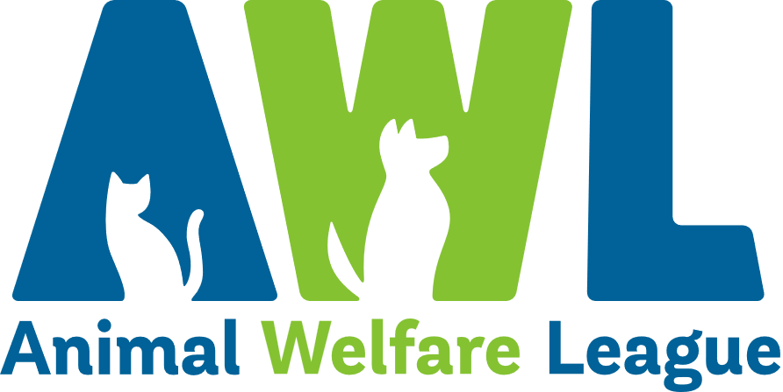
Position Description
Our Vision Our Mission
A South Australia where every pet has a loving home. Connecting pets, people and community.
About Us
Since our humble beginnings in 1964, Animal Welfare League has grown into one of South Australia’s leading animal welfare organisations. In our mission to connect pets, people and community, we find loving homes for vulnerable animals in need, reunite lost animals with their families and provide temporary shelter through our foster care program. We offer education and pet advice to the community to encourage responsible pet ownership and our social enterprises provide much-needed support to South Australians looking for pet boarding facilities and pet cremation and memorial services, as well as those on the lookout for a bargain at our Thrift Shops.

Create Opportunities | Show Compassion | Be Optimistic | Share Knowledge | Walk the Talk
Finding solutions to challenges  Being open minded to alternatives and new approaches  Striving to do better | Listening, observing and offering support  Being respectful  Being empathetic by taking the time to understand others’ points of view | Maintaining a positive outlook  Focusing on what’s possible and staying realistic  Remaining calm and composed during challenging times | Communicating openly and constructively  Using mistakes and feedback as an opportunity to learn  Seeking opportunities to develop our abilities and knowledge | Being open, honest and professional  Being accountable for outcomes and actions  Recognising and celebrating achievements
Our Beliefs and Behaviours
Position Description
Position Title: | Collection Services Officer | Tenure: | Casual
Department: | Cremations | Classification: | Level 1 / Level 2
Reports to: | Collection Services Supervisor | Direct Reports: | Nil

Position Overview
The Collection Services Officer is responsible for the efficient operation of cremations collections and deliveries, and successful face to face customer service.

Key Results Area
- Provide efficient and timely collection and delivery services in a dignified and respectful manner.  - Always promote a professional image of AWL.  - Collect deceased pets from vet clinics and private homes.  - Return pet’s ashes to customer homes and vet clinics.  - Complete all tasks efficiently and with a high level of accuracy.  - Achieve performance standards and operational KPIs.  - Assist with grooming, collection of paw prints, taking of fur clippings, transfer of ashes into urns and preparation of memorial products.  - Ensure all records are up to date and maintained. | - Understand and comply with all operational systems and procedures.  - Ensure all equipment is clean, maintained and used in an appropriate manner.  - Maintain sound and up-to-date knowledge of AWL Cremation’s products and services.  - Always work collaboratively with all AWL employees.  - Ensure and contribute to safe and effective operations.  - Participate in professional, respectful and courteous interactions, both written and verbal, with all stakeholders including members of the public.  - Ensuring a courteous and personable customer service experience and support implementation of customer service initiatives.  - Undertake other position appropriate duties as assigned/directed.

Personal Abilities | WHS and Compliance
Essential  - Experience in Production, Logistic and/or Customer Service industries.  - Demonstrable skills in customer-centric service provision including understanding of customer expectations and needs.  - Effective time management skills with the ability to learn, organise and prioritise workloads to meet deadlines.  - High level of written and verbal communication skills to interact with stakeholders at all levels.  - Ability to work independently with minimum supervision.  - Ability to work collaboratively and cooperatively within and across teams to achieve individual and team KPIs.  - Proven attributes including professionalism, reliable and trustworthy with a mature outlook.  - Strong attention to detail with a high level of accuracy.  - Ability to identify problems and assist in developing solutions, escalate if required.  - Intermediate computer literacy skills including use of Microsoft Office, email and internet. | All managers and employees of AWL are to:  - Comply with AWL’s organisational policies, procedures, guidelines and applicable legislative requirements including but not limited to Fair Work Act 2009 and Work Health and Safety Act 2012.  - At all times act and comply with reporting obligations arising from legislation, professional conduct standards including the Code of Code for AWL and organisational policies, procedures and guidelines.  - Take appropriate steps to protect themselves from risks to health and safety and to make sure they do not cause risk to others through any act or omission. In particular, the incumbent must:  - Report accidents, injuries, property damage and health and safety incidents.  - Use equipment provided to protect health and safety.  - Follow reasonable instructions and directions given on health and safety.  - Ensure they are not affected by alcohol or drugs so as to not endanger themselves or others.  - Understand and follow the requirements of confidentiality and facilitate appropriate standards of confidentiality and information sharing practice.  - Actively participate in AWL personal achievement and development processes.  - Participate in training and development activities as specified by AWL including those associated with workplace health and safety.
Special Requirements
- Some flexibility with working hours will be required. This includes working across a seven (7) day week, public holidays, peak holiday periods and if required covering shifts for leave absences.
- Travel will be required across AWL sites and other locations.
- A current driver’s licence is required.
- Applicants must be functionally assessed to ensure physical ability to complete the physical demands of the position.
- Satisfactory National Police Clearance Certificate / National Police Check (NPC) at commencement of employment and periodically at the request of AWL.

I have read the requirements and responsibilities outlined in this position description and will adhere to these conditions. I agree to have my performance monitored and
evaluated as detailed throughout this document.

Name: |  | Signed:
Date:

