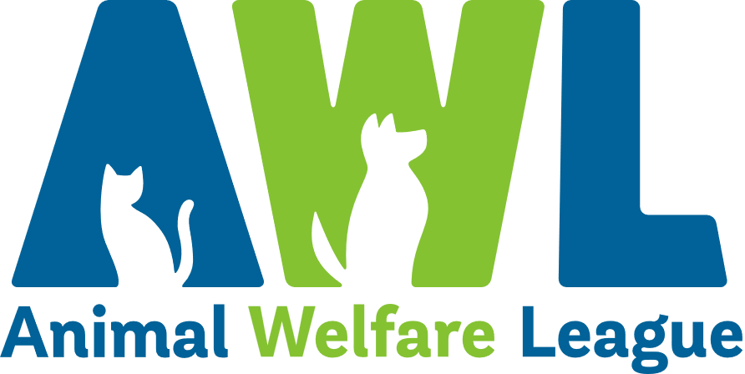
Position Description
Our Vision Our Mission
A South Australia where every pet has a loving home. Connecting pets, people and community.
About Us
Since our humble beginnings in 1964, Animal Welfare League has grown into one of South Australia’s leading animal welfare organisations. In our mission to connect pets, people and community, we find loving homes for vulnerable animals in need, reunite lost animals with their families and provide temporary shelter through our foster care program. We offer education and pet advice to the community to encourage responsible pet ownership and our social enterprises provide much-needed support to South Australians looking for pet boarding facilities and pet cremation and memorial services, as well as those on the lookout for a bargain at our Thrift Shops.

Create Opportunities | Show Compassion | Be Optimistic | Share Knowledge | Walk the Talk
Finding solutions to challenges  Being open minded to alternatives and new approaches  Striving to do better | Listening, observing and offering support  Being respectful  Being empathetic by taking the time to understand others’ points of view | Maintaining a positive outlook  Focusing on what’s possible and staying realistic  Remaining calm and composed during challenging times | Communicating openly and constructively  Using mistakes and feedback as an opportunity to learn  Seeking opportunities to develop our abilities and knowledge | Being open, honest and professional  Being accountable for outcomes and actions  Recognising and celebrating achievements
Our Beliefs and Behaviours

Position Description
Position Title: | Veterinarian | Tenure: | Ongoing - Full Time
Department: | Animal Operations - Vet Services | Classification: | N/A
Reports to: | Senior Veterinarian | Direct Reports: | Nil

Position Overview
The veterinarian is responsible for the provision of veterinary services at the Animal Welfare League South Australia (AWL). The Veterinarian will work closely with the Animal Care and Veterinary Services team to ensure that AWL remains at the forefront of providing innovative and quality services to the animals in our care.

Key Results Area
- Competently and confidently provide examination, diagnosis, advice, treatment and post-operative care to animals at AWL.  - Demonstrate skills in using equipment and / or interpreting results to treat more complex cases.  - Ensure all surgery and vaccination records are accurately maintained.  - Provide advice on improvements and changes to veterinary practice.  - Undertake health checks and routine checks of shelter and boarding animals as required.  - Ensure correct applications of medications.  - Appropriately identify and administer drugs and medications as required.  - Provide advice on drugs and medications.  - Observe safety procedures in relation to the administration, storage and application of drugs and medications. | - Ensure the clinic and all related practices, policies and procedures are maintained to the appropriate industry or legislative standards.  - Ensure all tasks are completed efficiently, accurately and promptly to meet required timeframes/deadlines.  - Follow AWL policies and procedures.  - Provide effective leadership to other clinic employees.  - Provide training and advice to managers and committees as required.  - Communicate effectively with relevant employees, clients and stakeholders.  - Provide relevant reports and information as requested.  - Undertake other position appropriate duties as assigned/directed.
Personal Abilities |  | WHS and Compliance
Essential  - Formal veterinary qualification and current registration with the Veterinary Surgeons Board of South Australia.  - Demonstrated commitment and understanding of issues relating to animal welfare.  - Demonstrate business acumen.  - Commitment to maintaining a positive culture that connects with the mission, vision and strategic direction of AWL.  - Ability to learn, prioritise tasks and demonstrate effective time management skills to meet required timelines.  - Proven experience working effectively both independently and as part as team to achieve individual and team KPIs.  - Outstanding communication skills both written and verbal with strong attention to detail.  - Demonstrated ability in applying rational objectivity and being empathetic in a sensitive environment.  - Ability to undertake a thorough and methodical approach when carrying out all work tasks/duties.  Desirable  - Experience working in a shelter or pound environment.  - Intermediate computer literacy including proficiency with database management and experience in Sheltermate/ShelterBuddy is highly desirable. |  | All managers and employees of AWL are to:  - Comply with AWL’s organisational policies, procedures, guidelines and applicable legislative requirements including but not limited to Fair Work Act 2009 and Work Health and Safety Act 2012.  - At all times act and comply with reporting obligations arising from legislation, professional conduct standards including the Code of Code for AWL and organisational policies, procedures and guidelines.  - Take appropriate steps to protect themselves from risks to health and safety and to make sure they do not cause risk to others through any act or omission. In particular, the incumbent must:  - Report accidents, injuries, property damage and health and safety incidents.  - Use equipment provided to protect health and safety.  - Follow reasonable instructions and directions given on health and safety.  - Ensure they are not affected by alcohol or drugs so as to not endanger themselves or others.  - Understand and follow the requirements of confidentiality and facilitate appropriate standards of confidentiality and information sharing practice.  - Actively participate in AWL personal achievement and development processes.  - Participate in training and development activities as specified by AWL including those associated with workplace health and safety.
Special Requirements
- Some flexibility with working hours will be required. This includes working across a fourteen (14) day roster including weekends and public holidays.
- Additional hours may be required to meet business needs.
- Ability to work across any AWL site or location.
- A current driver’s licence is required.
- Satisfactory National Police Clearance Certificate / National Police Check (NPC) at commencement of employment and periodically at the request of AWL.
I have read the requirements and responsibilities outlined in this position description and will adhere to these conditions. I agree to have my performance monitored and
evaluated as detailed throughout this document.
Name: |  | Signed:
Date:

