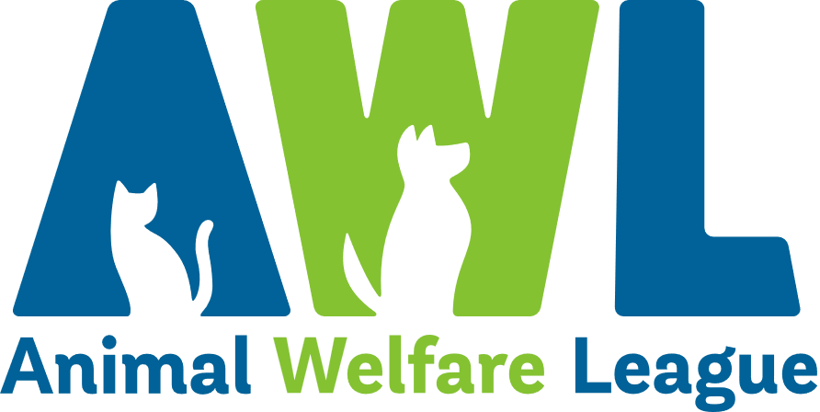
Position Description
Our Vision Our Mission
A South Australia where every pet has a loving home. Connecting pets, people and community.
About Us
Since our humble beginnings in 1964, Animal Welfare League has grown into one of South Australia’s leading animal welfare organisations. In our mission to connect pets, people and community, we find loving homes for vulnerable animals in need, reunite lost animals with their families and provide temporary shelter through our foster care program. We offer education and pet advice to the community to encourage responsible pet ownership and our social enterprises provide much-needed support to South Australians looking for pet boarding facilities and pet cremation and memorial services, as well as those on the lookout for a bargain at our Thrift Shops.

Create Opportunities | Show Compassion | Be Optimistic | Share Knowledge | Walk the Talk
Finding solutions to challenges  Being open minded to alternatives and new approaches  Striving to do better | Listening, observing and offering support  Being respectful  Being empathetic by taking the time to understand others’ points of view | Maintaining a positive outlook  Focusing on what’s possible and staying realistic  Remaining calm and composed during challenging times | Communicating openly and constructively  Using mistakes and feedback as an opportunity to learn  Seeking opportunities to develop our abilities and knowledge | Being open, honest and professional  Being accountable for outcomes and actions  Recognising and celebrating achievements
Our Beliefs and Behaviours
Position Description
Position Title: | Veterinary Nurse | Tenure: | Ongoing / Temporary - Full Time / Part Time
Department: | Animal Operations - Vet Services | Classification: | Level 3
Reports to: | Veterinary Services Operations Manager | Direct Reports: | Nil
Position Overview
As a member of the Veterinary Team this position is responsible for maintaining a standard of care and expertise that contributes to the effective running of the Veterinary Clinic.

Key Results Area
Surgical Duties  - Prepare clinic for daily surgery.  - Assist with surgery preparation and monitoring anaesthesia.  - Clean and maintain surgery packs and ensure suitability and sterility for use.  - Ensure surgery records are accurately maintained.  Drugs and Medication  - Maintain stock control in conjunction with Procurement team.  - Dispense medications and ensure correct application and administration of medications under veterinary direction.  - Ensure accurate recording of medications administered.  - Observe and support other staff to follow WHS practices.  Reception Duties  - Maintain a high level of customer service.  - Give general animal health advice.  - Ensure animal care records are accurately maintained.  - Promptly answer telephone and general enquiries as required.  Administration  - Maintain patient files and bookwork.  - Book and ensure appointments are maintained accurately.  - Ensure surgery and treatment lists are maintained accurately. | - Maintain clear concise communication with key service areas of the AWL and external stakeholders.  Hygiene maintenance  - Ensure all cages are clean.  - Use appropriate cleaning products and disinfectants.  - Sterilize all surgical equipment, packs and drapes.  - Dispose of surgical waste correctly.  - Maintain hygiene and cleanliness of clinic at industry standard levels.  General Duties  - Check animals post operatively during recovery.  - Assist veterinarians with consultations, examinations and treatments in the Shelters.  - Nursing hospitalised animals including neonatal patients, wound management,  supplementary feeding and exercising.  - Check all animals before leaving premises at end of shift.  - Assist and perform euthanasia as required under veterinary direction.  - Lead, develop and train AWL employees to ensure that they provide exceptional animal care.  - Provide employees, foster carers and clients with general health and nutritional advice.  - Maintain knowledge on AWL policies, procedures, legislation, in relation to Animal Care and ownership.  - Undertake other position appropriate duties as assigned/directed.
Personal Abilities | WHS and Compliance
Essential  - Certificate IV in Veterinary Nursing.  - Minimum two (2) years’ experience working with companion animals in a clinical setting.  - Compassion for and an interest in animal welfare and care.  - A commitment to continuous learning and improvement.  - Proven relationship management skills and ability to communicate effectively with stakeholders at all levels.  - Exceptional surgical and anaesthesia skills.  - Excellent animal health and behaviour knowledge.  - Well developed understanding of infection prevention and control practices.  - Sound administrative skills with a high level of accuracy and record keeping, and ability to maintain confidentiality.  - Ability to work collaboratively and cooperatively within and across teams to achieve individual and team KPIs.  - Ability to assist with assessments for re-homing.  - High level of professionalism and ability to following policies, procedures and directions.  - Accredited microchip implanter or willingness to seek accreditation.  - Accredited and competent euthanasia technician. | All managers and employees of AWL are to:  - Comply with AWL’s organisational policies, procedures, guidelines and applicable legislative requirements including but not limited to Fair Work Act 2009 and Work Health and Safety Act 2012.  - At all times act and comply with reporting obligations arising from legislation, professional conduct standards including the Code of Code for AWL and organisational policies, procedures and guidelines.  - Take appropriate steps to protect themselves from risks to health and safety and to make sure they do not cause risk to others through any act or omission. In particular, the incumbent must:  - Report accidents, injuries, property damage and health and safety incidents.  - Use equipment provided to protect health and safety.  - Follow reasonable instructions and directions given on health and safety.  - Ensure they are not affected by alcohol or drugs so as to not endanger themselves or others.  - Understand and follow the requirements of confidentiality and facilitate appropriate standards of confidentiality and information sharing practice.  - Actively participate in AWL personal achievement and development processes.  - Participate in training and development activities as specified by AWL including those associated with workplace health and safety.
Special Requirements
- Some flexibility with working hours will be required. This includes working across a fourteen (14) day roster including public holidays and weekends.
- Additional hours may be required to meet business needs.
- Ability to work across any AWL site or location.
- A current driver’s licence is required.
- Applicants must be functionally assessed to ensure physical ability to complete the physical demands of the position.
- Satisfactory National Police Clearance Certificate / National Police Check (NPC) at commencement of employment and periodically at the request of AWL.

I have read the requirements and responsibilities outlined in this position description and will adhere to these conditions. I agree to have my performance monitored and
evaluated as detailed throughout this document.

Name: |  | Signed:
Date:

